**Assignment 04**

**Notepad**

**Assigned date :** 06-Dec-2024

**Due Date :**  20-Dec-2024

**Student’s Details :** Abeera (SP24-BSE-004**)**

Nafeesa Mushtaq (SP24-BSE-096)

**Welcome Page**

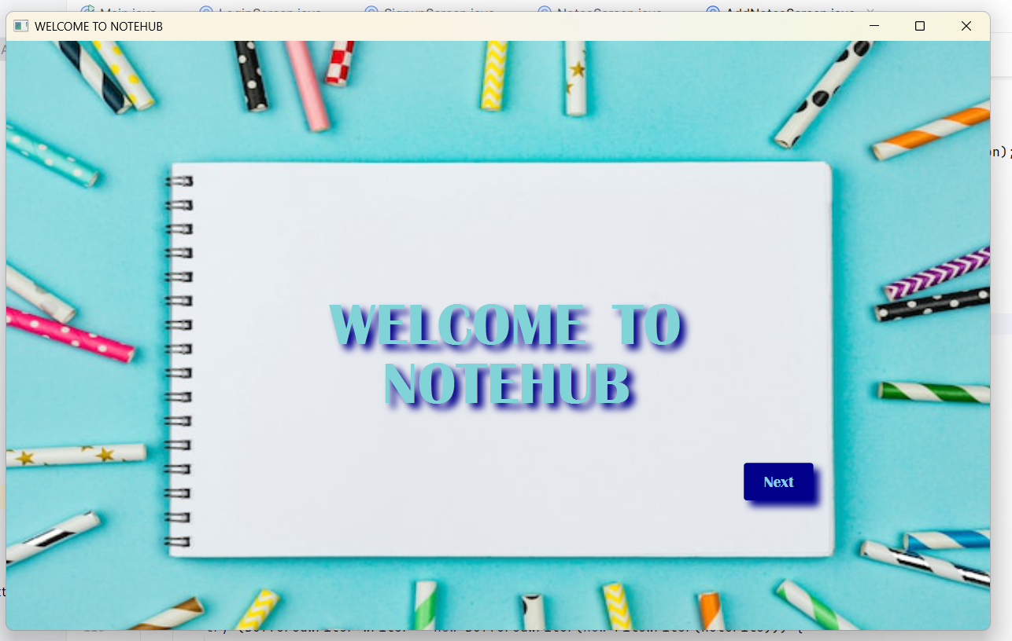

**Second Page**

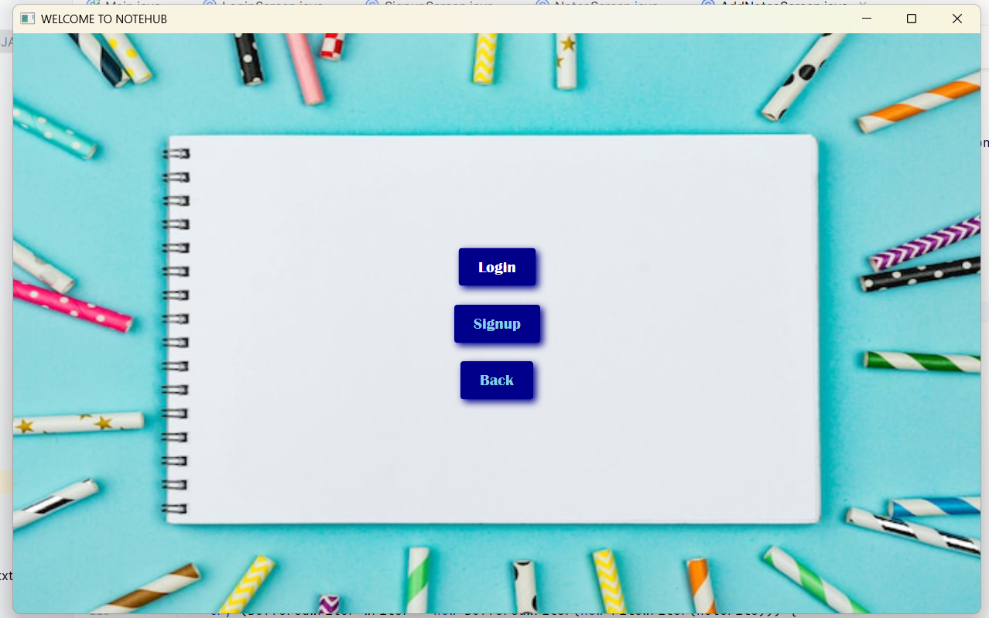

**Login page**

**SignUp Page**

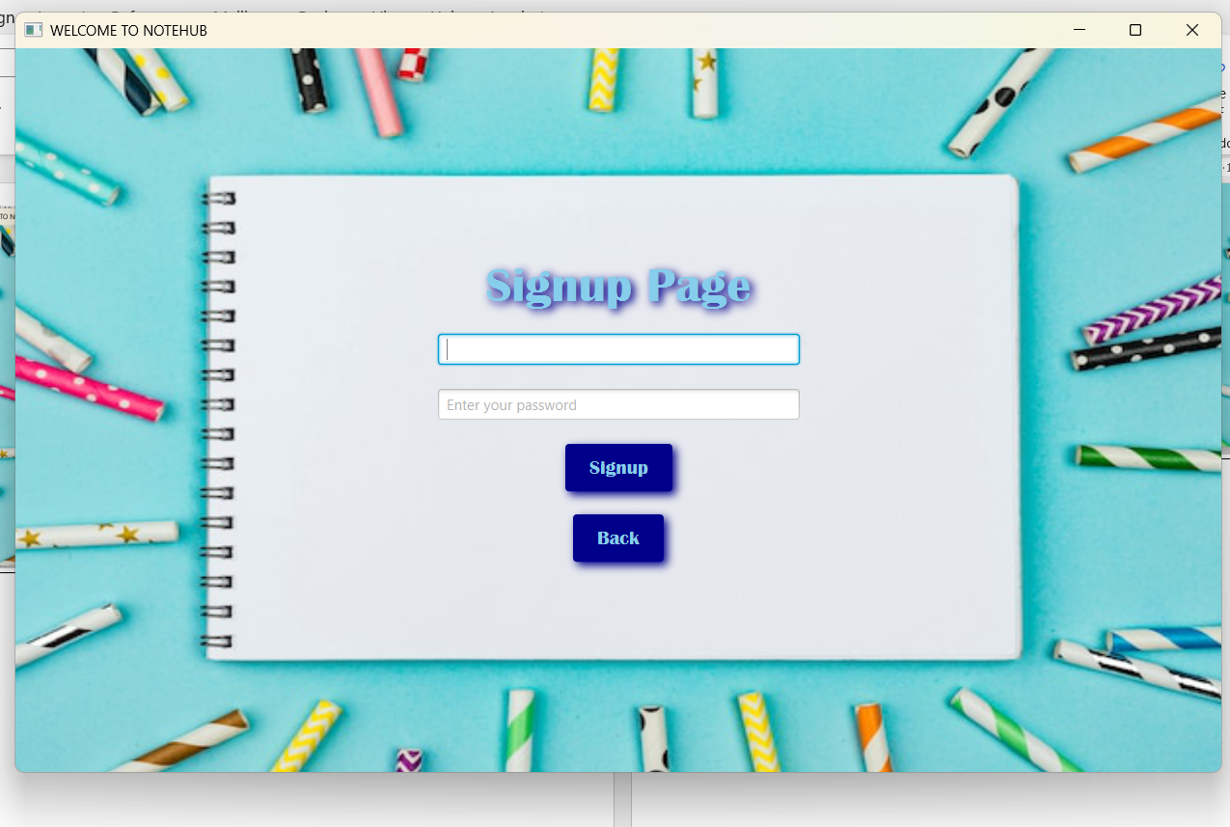

**Menu Page**

**Add Notes**

**View, Edit and Delete**

**Edit Notes**

**Read Note**

